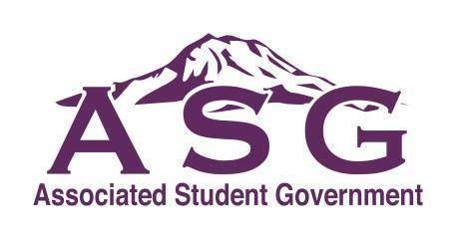

Student Council for Clover Park

Technical College
Study Session & Meeting Minutes

January 7th, 2019

Call to Order
The meeting of the Student Council for Clover Park Technical College was called to order at 2:30pm on January 7th, 2019 in building 23 room 215 by the President Sam Hardy.

Roll Call & Audience Introductions
President of Student Council - Sam Hardy
Vice-President - Tim Kvamme
Legislative Officer - Sadie Hollenbach
Clubs and Emergency Officer - Quan Tran
Public Relations Officer - Sandra Lopez
Assistant Director of Student Life - Story Gilmore

General Discussion
- We all go to guided pathways, just different groups. Access to affordable books and materials is Sadie and Sam. Active Shooter is Sadie and Sam. Access to library, computer lab and tutoring is Tim, Quan, and Sandra. Student Success in Math is Tim, Quan, and Sam.
- Schedules, we work on outlook and whenIwork, story doesn't want to use outlook just whenIwork. For Student council she feel like it should be self directed. She will post our schedules to match our availability. If you drop your shift just let Story know so she is updated.
- Our projects will be our priorities but we also have little projects we work on as they come up.
- Sadie and Sam can't make it to all hazards so Sandra and Tim will be going. The fourth Tuesday of every month starting at 2pm building 17 room 107.
- OER is Sadie and Sandra. Marica is included, she started the paper for resources and is drafting an email to figure out who has a book loan program that is managed through and supported by student fees. Story wanted to start one through the SLSC and have student government involved. We need to know price, what books, how it works and what they they do to manage.
- Meetings, might make more sense to do in the priority groups.
- Advocacy day, emails have been sent. This is the 24, 8am-4pm , Sam and Sandra cant make it. Sadie, Tim and Quan can go.
Approval of agenda
Sandra Lopez motioned for the approval of agenda, Quan Tran seconded, and motion carries.
Approval of minutes from 12/05/2018
Moved to Old Business.

Presidents Report
All hazards is hosting Active shooter events, 3 in February all 3 hours long. Our graphics member, Jeanna did the poster for this event and she is proud.

Vice-President Report
Week of Welcome was a great success, everyone enjoyed the events and there was a big turn out for hot cocoa.

Clubs and Emergency Officer Report
Was gone for vacation so didn't have a chance to much yet. Thank you Story for taking on this position in Cals absences.

Legislative Officer Report
Preparation for advocacy day, talked about lunch with legs and getting posters out. SHe has messaged multiple legs and now waiting for responses. She will be getting in contact with Tony Dotson.

Public Relations Officer Report
I need to look into committee meeting to figure out my schedule. Week of welcome was great new students seemed to apparate us there for classes, financial aid, advising so it was nice to be there for those new students. A safety fair is going to be a combination of things for health and safety.

Advisor Report
Sent out the Monday memo with dates and times including the club council from 3-4 in room 209 and the BOT on the 9th in the rotunda and campus activities doing a movie night in the ballroom Friday. Check the Monday Memo, let Story know if anything is missing or wrong. Story will be scheduling meetings based on priorities. She will also be scheduling based on the hours we put in
Public comment
None

New Business
- Action item 19-1 OER Delegation
This was discussed in the study session, Sadie and Sandra will be helping Marica with this. The motion was approved.
- Action Item 19-2 Leg meeting was discussed in the study session.

Old Business
none
Good of the order
Adjournment
The meeting was adjourned on January 7th, 2017 at 3:15pm

